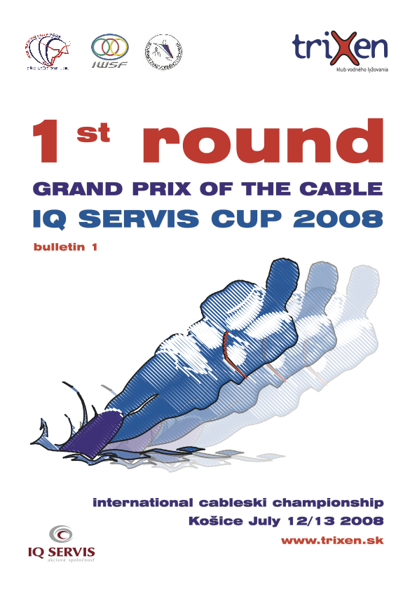

The Water Ski Club triXen and Slovak Water Ski Federation invite you to the 1st round of Grand prix of the cable 2008. IQ SERVIS CUP from 12th of July till 13th of July 2008

1. Venue and Organizer:
Water sports area TRIXEN - Sídlisko Nad Jazerom, Košice
Klub vodného lyžovania TRIXEN, Garbiarska 5, 040 01 Košice, Slovak Republic www.trixen.sk

Alexander Vaško ml.
vasko@iqservis.sk, +421 903 623 112

2. Conditions of the Competition:
The competition will be held at the Cableway in Košice /Slovak Republic, as the final part of GRAND PRIX series 2008
Events: Tricks, Slalom, Jump and overall.
Rules: The competition will be held according to the IWSF World Cableski Technical Rules 2008 and the Grand prix of the cable Rules 2008

3. Categories:
The competition will be carried out in the following Categories:
Junior boys and girls U 15, junior boys and girls U 19 years, open men and open women

4. Homologation:
This competition will be Ranking list homologated.

5. Drawing facility:
RIXEN Cableway (4 pulleys)/Direct drive

6. Applications:
The entry form of the participants must be available latest 10. July 2008 to the Organizer:

Klub vodného lyžovania TRIXEN, Alexander Vaško, Garbiarska 5, 040 01 Košice, Slovak republic
E-mail: vasko@iqservis.sk Fax: +421-55-633 39 85

7. Judges
You can find nominated judges on official cableski websites.

8. Entry fee:
The organizer collects an entry fee per skier of 40 Euros for 3 events and 15 Euros for single event. The entry fee must be paid in Euros in the competition office before training starts.
Training is unofficial - 1 hour/3 000,- Sk or 100 Euro

9. Time schedule:
Tuesday 07:00 – 12:00/17:00 – 20:00 practice possibilities for teams

Thursday 07:00 – 20:00 practice possibilities for teams

Friday 10:00 – 17:00 practice possibilities for teams
16:00 – 18:00 Accreditation of the participants
17:00 – 20:00 Official training (1 round/per skier/per disciplines)
19:00 Captain and Jury meeting

Saturday 08:00 Competition (preliminary rounds)
20:00 Evening party

Sunday 09:00 Competition (final rounds)
17:00 Prize giving ceremony

The time schedule can be altered by decision of the judges.

10. Liability:
The organizing club does not undertake any liability for damage to persons, material or property against competitors, Technical Official (TO), judges, official helpers and other persons.
All competitors take part on their own risk in every respect even if they are engaged out of the competition, e.g. in any additional program. With the entry of the competition they give up any claim
from cases of loss of any kind arising indirectly or directly during this event. Actives ought to have affected a private accident insurance besides their health insurance. Damage to a third party (e.g. spectators) is insured only within the limits of the organizer’s liability.

11. Accommodations:
Hotel Akadémia**
Južná trieda 10, Košice, Tel.: +421-55-7260 700
e-mail: recepcia@zsjuznake.sk, www.hotelakademia.sk
Hotel Cell part
Single room 1200 Sk Double room in the cell 1000 Sk
Double bed room 1800 Sk
Triple bed room 1950 Sk
Apartment 2100 Sk

Hotel u Leva**
Alejová 2, Košice Tel.: +421-55-643 02 33
E-mail: penzion@penzionuleva.sk, www.penzionuleva.sk
Single room 1450 Sk
Double bed room 2250 Sk/per two 1850 Sk / per one
Apartments 3000 Sk per two

Autocamping Salač BARCA
Alejová 24, Barca, Košice Tel.: +421-55-623 33 97
Double bed room 700 Sk
Triple bed room 1050 Sk
Five bed room 1750 Sk

Tourist Accommodation Medická
Medická 2, Košice Tel.: +421-55-643 56 88, 642 90 52
E-mail: dmmed@kosice.upjs.sk, www.dmmed.kecom.sk

Simple room 420 Sk/per person/per night
Triple bed room 280 Sk/per person/per night

For booking please contact directly the hotels.

12. Exchange rate:
Current exchange rate from 2nd June 2008, 1 EUR/30,331 Sk

13. Description of the route:
By Plane
If you insist on arriving in Kosice by air, there's an international airport Kosice that has scheduled daily connections from Wien, Prague, Budapest and Bratislava.

Airport Budapest to Kosice  260 km, Airport Bratislava to Košice  400 km
Airport Prague to Kosice  750 km, Airport Vienna to Kosice  460 km
Notice: The Organizer will provide transport free of charge from the Kosice airport to the lake. Please fill in the application form for transport, which will be attached in Bulletin.
By Car
You can get to Kosice from Bratislava road E571, from Miskolc road E71 and from Presov road E50.

We are looking forward to your participation.

In the name of KVL TRIXEN
Alexander Vaško

Water Ski Club TRIXEN

Entry form

1st round Grand prix of the cable 2008

IQ SERVIS CUP
12th – 13th of July

Country: Club:

 | Name | Date of birth | Category | Slalom | Tricks | Jump | Ramp
1.
2.
3.
4.
5.
6.
7.
8.
9.
10.

Transport:

Plane or Train | Number of persons | Date of  arrival | Time of  arrival | Date of departure | Time of departure

Date:

The entry form of the participants must be available latest 10th July 2008 to the Organizer:

Klub vodného lyžovania TRIXEN, Alexander Vaško, Garbiarska 5, 040 01 Košice, Slovak republic

E-mail: vasko@iqservis.sk, Fax: +421-55-633 39 85

