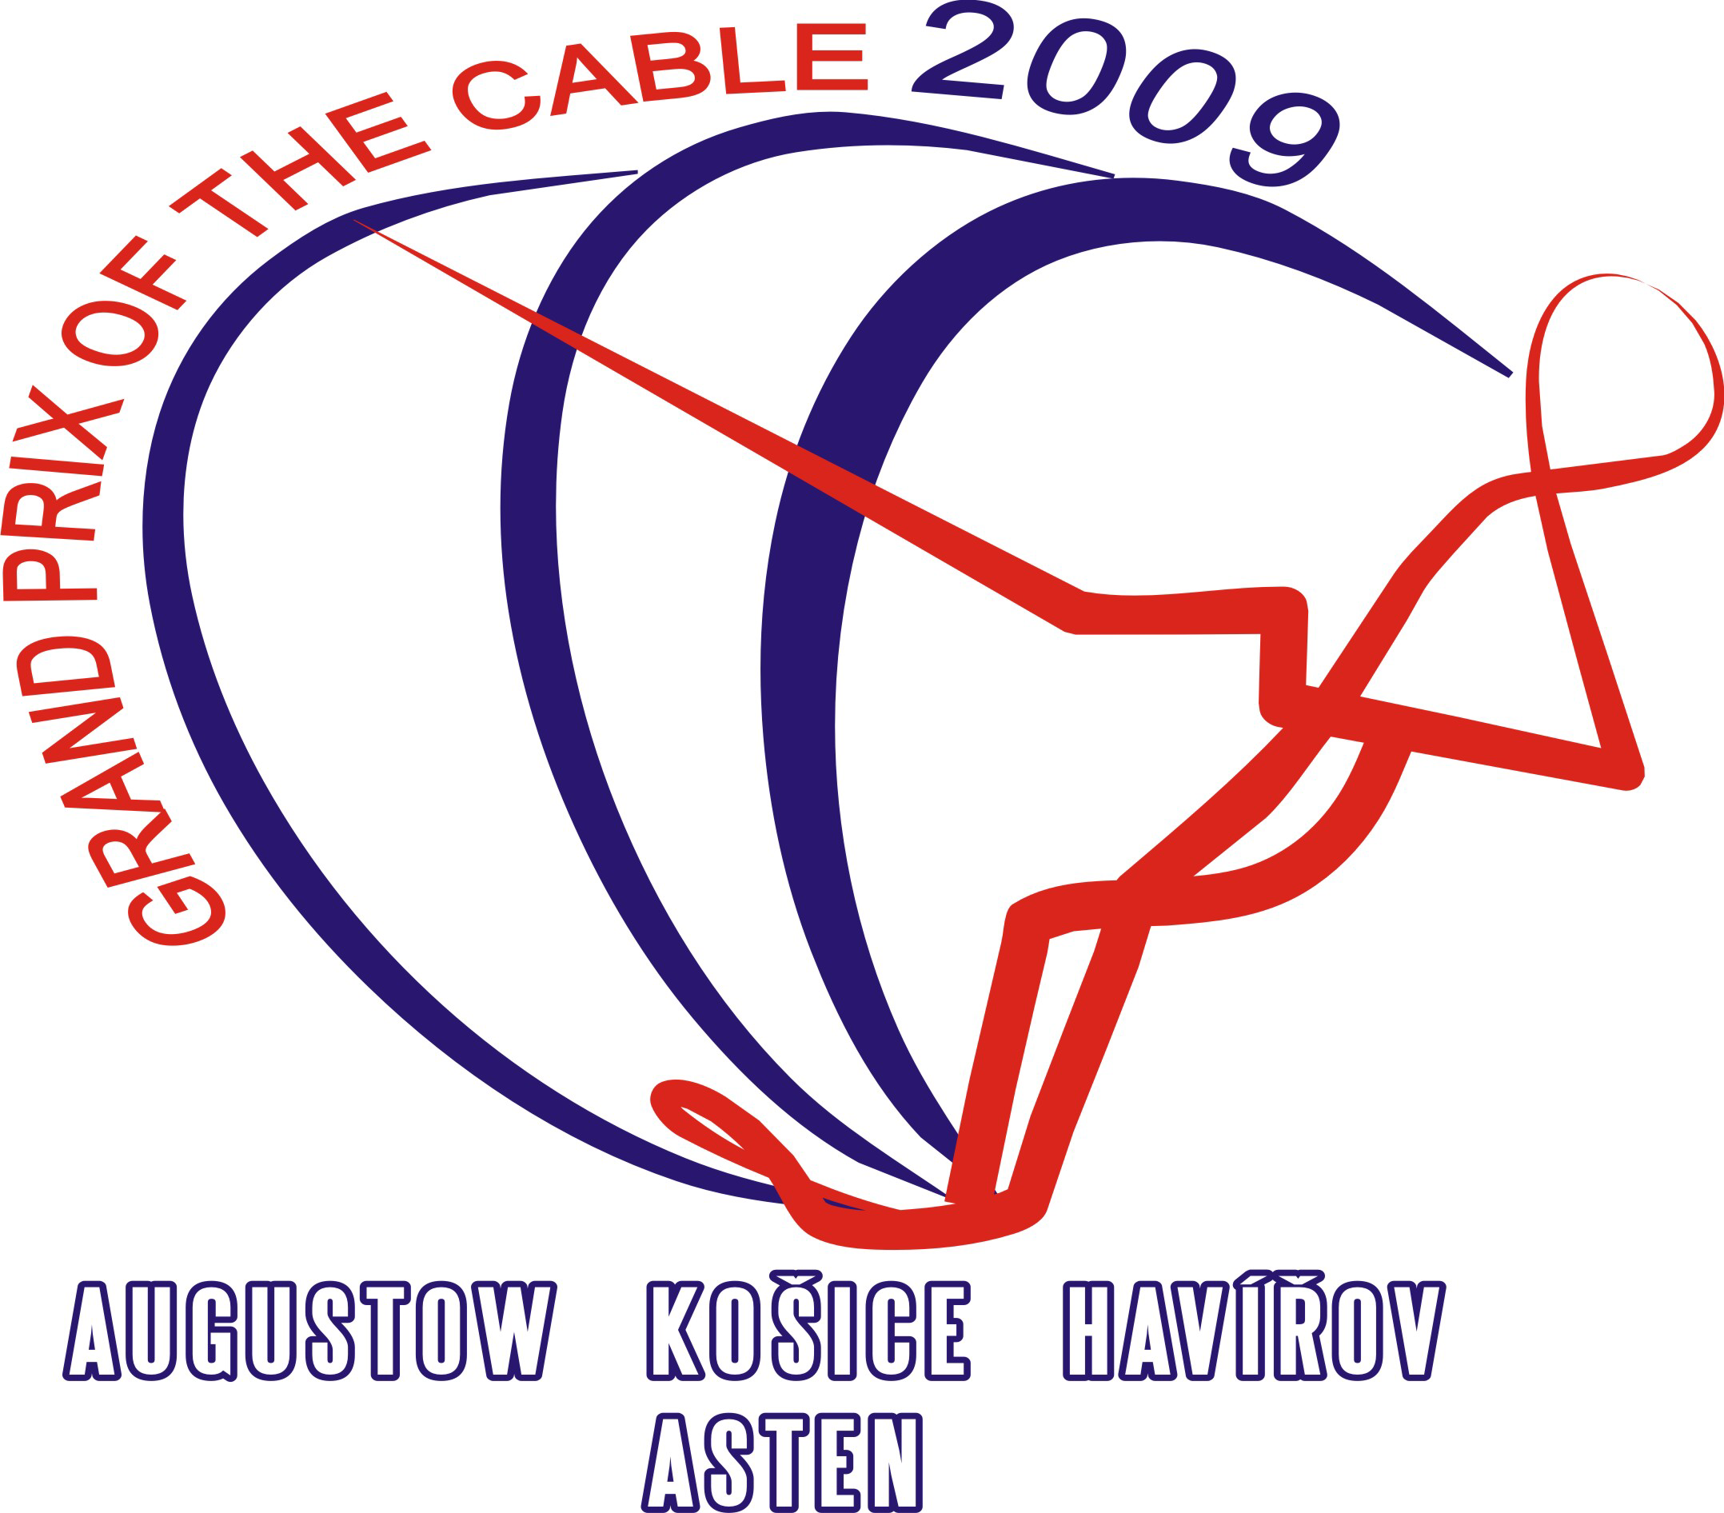

Grand prix of the cable – Havířov 2009
The part of the International Grand prix serie, Havirov, 1st-2nd of August

I N V I T A T I O N

We invite all members federations of the EAME to the Grand prix of the cable 2009, which will be held on 1st to 2nd of August at WSC Havirov on Terlicko lake.

1. Organiser:
Waterski club Havirov
Bludovicka 755/4
736 01 Havirov - Mesto
Czech Republic

2. Conditions of the Competition:
The competition will be held as the part of Grand prix serie 2009 at the Cableway in Těrlicko -Czech Republic in the following disciplines: Tricks, Slalom, Jump and their overall. The competition will be carried out according to the rules of the IWSF World Cableski Technical Rules 2009 and the rules of Grand prix of the cable 2009.

3. Categories:
The competition will be carried out in the following Categories:
open men and women, junior girls and boys U 19, junior girls and boys U 15

4. Homologation:
This competition will be Rankinglist - homologated.

5. Drawing facility:
VLV X - 001 - MOTORSPORT Cableway (4 pulleys)

6. Applications:
The entry form of the participants must be available latest 20th of July 2009 to the Organizer :

Water ski club Havirov
Martin Kocur
Bludovicka 755/4
73601 Havířov, Czech republic
E-mail: martinkocur@seznam.cz

7. Judges
You can find nominated judges on official cableski websites.

8. Entry fee:
The organiser collects an entry fee per skier of 40 Euros for 3 events and 15 Euros for single event. The entry fee must be paid in Euros in the competition office before training starts.

9. Time schedule:
Friday, 31st of July 15:00 - 19:00 Presentation
16:00 - 19:00 Official training
19:00 – 21:00 Homologation
20:00 Captain and Jury meeting
Saturday, 1st of August 08:00 Competition (preliminary rounds)
20:00 Evening party
Sunday, 2nd of August 09.00h Competition (final rounds)
15:00 Prize giving ceremony

The time schedule can be altered by decision of the judges.

10. Prizes:
Medals for the first, second and third place in all events and cups for the overal.

11. Liability:
The organising club does not undertake any liability for damage to persons, material or property against competitors, Technical Official (TO), judges, official helpers and other persons.
All competitors take part on their own risk in every respect even if they are engaged out of the competition, e.g. in any additional program. With the entry of the competition they give up any claim from cases of loss of any kind arising indirectly or directly during this event. Actives ought to have effected a private accident insurance besides their health insurance. Damage to a third party (e.g. spectators) is insured only within the limits of the organiser's liability.

12. Special offer
The owner of the cable will arrange reservation of the Cableski installation from Monday 27th of July to Friday 31st of July 2008 till 15:00. The price is 80.00- € per hour or 2200,- CZK
E-mail reservation: martinkocur@seznam.cz

13. Accommodations:
All competitors shall have a look to their accommodations themselves.
The distance from the cable to all hotels is aprox. 5 km.
The recommendation of hotels:

* Hotel PERMONÍK (Zátoka) - Těrlicko lake

fax : +420 596 423 090
e-mail : permonik@cmail.cz
web.: www.areal-permonik.cz
2 bedroom de Luxe: 350,- or 400,- CZK/per person
2,3 or 4 bedroom: 250,-CZK/per person
Bungalows: 9, 8 or 6 person = 200,-CZK/per person

* Penzion TAREM – Těrlicko lake
mobil: +420602722038
2 bedroom: 300 ,- CZK/per person

* Hotel&Restaurant Fridrich – Těrlicko lake
web: www.hotelfridrich.cz

For the help with accomodation contact us please: martinkocur@seznam.cz

14. Description of the route:
By car: - direct to Ostrava and from Ostrava to Český Těšín; in the middle of the way you
will reach Havířov – Těrlicko.
- direction from the border with Poland: direct to Havířov and you will passTěrlicko
lake on the way
By plane: direct to Ostrava-Mošnov airport. The Organizer will provide transport free of charge from the airport to the Těrlicko lake.

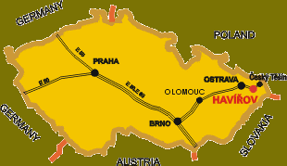

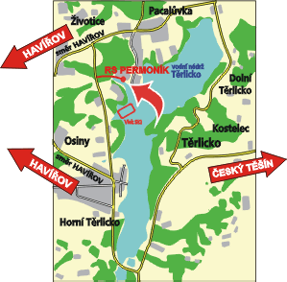

We are looking forward to your participation.

In the name of WSC Havířov
Josef Kocur


WATERSKI CLUB

HAVÍŘOV

Entry form

Grand prix of the cable 2009

1st – 2nd of August 2009

Country: Club:

 | Name | Date of birth | Category | Slalom | Tricks | Jump | Ramp
1.
2.
3.
4.
5.
6.
7.
8.
9.
10.

The entry form of the participants must be available latest 20th of July 2009 to the Organizer :

Water ski club Havířov
Martin Kocur

Bludovicka 755/4
73601 Havířov, Czech republic
E-mail: martinkocur@seznam.cz

