Grand prix of the cable – European cup
The final of the Grand prix serie, Havirov, 6th - 8th of August 2010

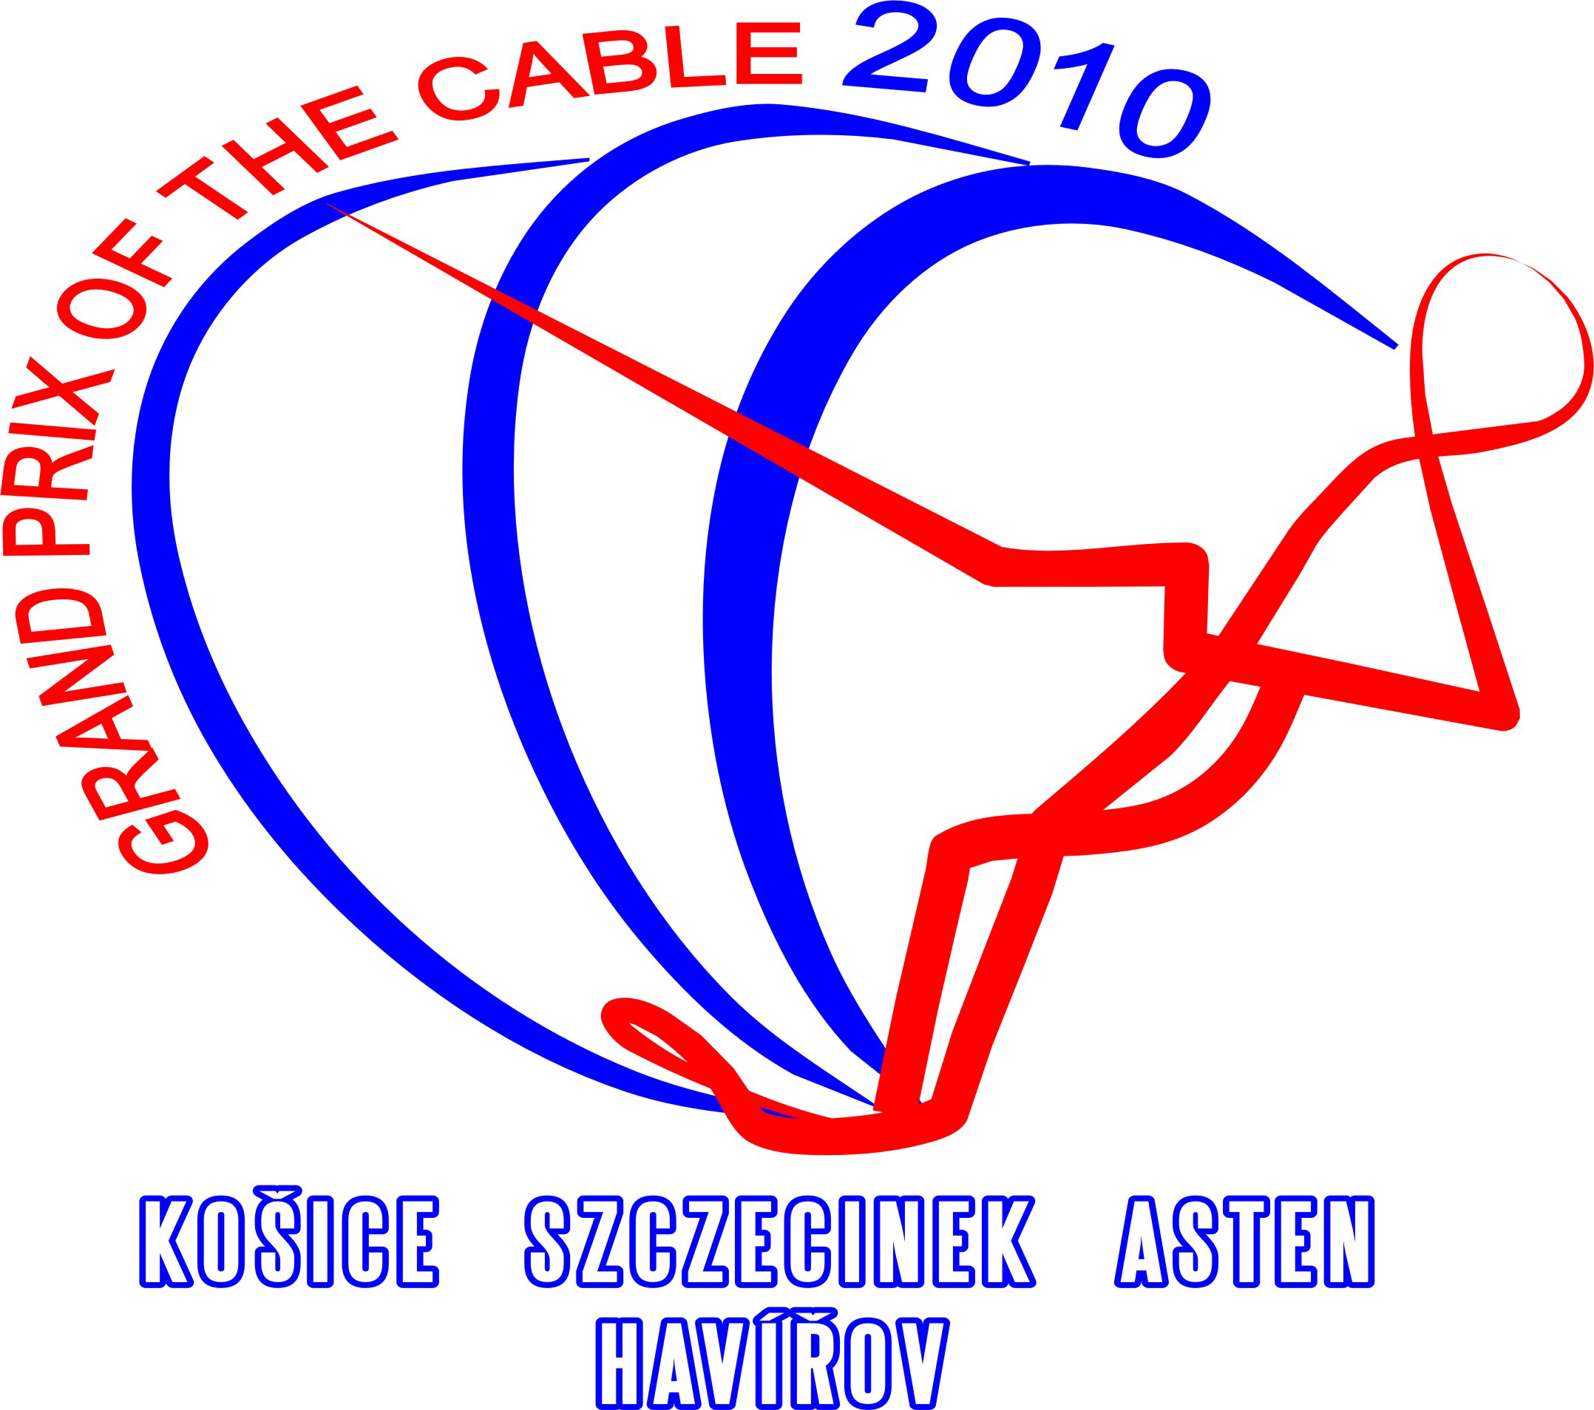


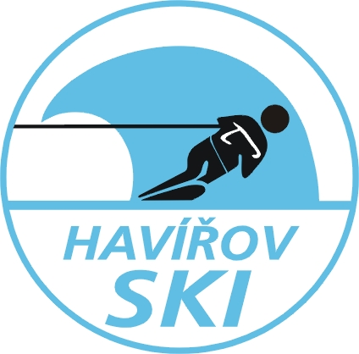


I N V I T A T I O N

We invite all members federations of the E&A to the Grand prix of the cable 2010 – European cup, which will be held on 6th to 8th of August at WSC Havirov on Terlicko lake.

1. Organiser:
Waterski club Havirov
Bludovicka 755/4
736 01 Havirov - Mesto
Czech Republic

2. Conditions of the Competition:
The competition will be held as the final of Grand prix serie 2010 at the Cableway in Těrlicko -Czech Republic in the following disciplines: Tricks, Slalom, Jump and their overall. The competition will be carried out according to the rules of the World Cableski Technical Rules 2010, and the rules of Grand prix of the cable 2010.

3. Categories:
The competition will be carried out in the following Categories:
open men and women, junior girls and boys U 19, junior girls and boys U 15

4. Homologation:
This competition will be Rankinglist - homologated.

5. Drawing facility:
VLV X - 001 - MOTORSPORT Cableway (4 pulleys)

6. Applications:
The entry form of the participants must be available latest 2nd of August 2010 to the Organizer :

Water ski club Havirov
Martin Kocur
Bludovicka 755/4
73601 Havířov, Czech republic
E-mail: martinkocur@seznam.cz

7. Judges
You can find nominated judges on official cableski websites.

8. Entry fee:
The organiser collects an entry fee per skier of 60 Euros for 3 events and 25 Euros for single event. The entry fee must be paid in Euros in the competition office before training starts.

9. Time schedule:
Friday, 6th of August 15:00 - 19:00 Presentation
16:00 - 19:00 Official training
19:00 – 21:00 Homologation
20:00 Captain and Jury meeting
Saturday, 7th of August 08:00 Competition - preliminary rounds (slalom, trick, jump)
20:00 Evening party
Sunday, 8th of August 09.00h Competition - final rounds (slalom, trick, jump)
15:00 Prize giving ceremony

The time schedule can be altered by decision of the judges.
10. Prizes:
Medals for the first, second and third place in all events in all categories and cups for the overal.

11. Liability:
The organising club does not undertake any liability for damage to persons, material or property against competitors, Technical Official (TO), judges, official helpers and other persons.
All competitors take part on their own risk in every respect even if they are engaged out of the competition, e.g. in any additional program. With the entry of the competition they give up any claim from cases of loss of any kind arising indirectly or directly during this event. Actives ought to have effected a private accident insurance besides their health insurance. Damage to a third party (e.g. spectators) is insured only within the limits of the organiser's liability.

12. Special offer
The owner of the cable will arrange reservation of the Cableski installation from Monday 2nd of August to Friday 6th of August 2010 till 15:00. The price is 100.00,- € or 2500,- CZK per hour.
E-mail reservation: martinkocur@seznam.cz

13. Accommodations:
All competitors shall have a look to their accommodations themselves.
The distance from the cable to all hotels is aprox. 5 km.
The recommendation of hotels:

* Hotel PERMONÍK (Zátoka) - Těrlicko lake

fax : +420 596 423 090
e-mail : permonik@cmail.cz
web.: www.areal-permonik.cz
2 bedroom de Luxe: 350,- or 400,- CZK/per person
2,3 or 4 bedroom: 250,-CZK/per person
Bungalows: 9, 8 or 6 person = 200,-CZK/per person

* Penzion TAREM – Těrlicko lake
mobil: +420 608 402 333
web: www.penziontarem.cz
2 bedroom: 250 ,- CZK/per person

* Hotel&Restaurant Fridrich – Těrlicko lake
mobil: +420 777 073 844
web: www.hotelfridrich.cz

* Hotel Jaškovská krčma - Těrlicko lake
tel.: +420 596 423 226
mobil: +420 602 269 734
web: www.jaskovskakrcma.cz

For the help with accomodation contact us please: martinkocur@seznam.cz

14. Description of the route:
By car: - direct to Ostrava and from Ostrava to Český Těšín; in the middle of the way you
will reach Havířov – Těrlicko.
- direction from the border with Poland: direct to Havířov and you will passTěrlicko
lake on the way
By plane: direct to Ostrava-Mošnov airport. The Organizer will provide transport free of charge from the
airport to the Těrlicko lake.

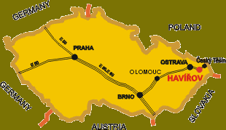

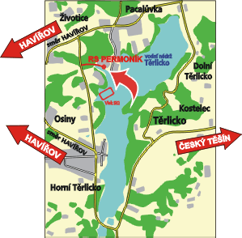

We are looking forward to your participation.

In the name of WSC Havířov
Martin Kocur

WATERSKI CLUB

HAVÍŘOV

Entry form

Grand prix of the cable 2010 – European cup

Havířov, 6th – 8th of August 2010

Country: Club:

 | Name | Date of birth | Category | Slalom | Tricks | Jump | Ramp
1.
2.
3.
4.
5.
6.
7.
8.
9.
10.

The entry form of the participants must be available latest 2nd of August 2010 to the Organizer :

Water ski club Havířov
Martin Kocur

Bludovicka 755/4
73601 Havířov, Czech republic
E-mail: martinkocur@seznam.cz

